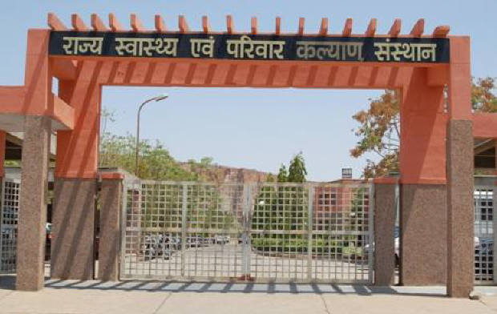
SIHFW Rajasthan

Electronic Newsletter
October to December 2023 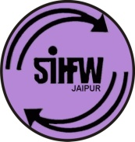
SIHFW: an ISO 9001:2015 certified Institution

From the Director’s desk…

Dear Friends…

Happy New Year 2024 Greetings from SIHFW!!

As we all know, Wellbeing is so important in our life. International Mind-Body Wellness Day is celebrated on January 3 every year. It is an attempt to promote self-care, mindfulness and healthy practices to make people aware of the mind-body connection. This day celebrates harmonious co-existence of physical and mental health. The connection between our mind, body and spirit is crucial to our wellness. Theme for year 2024, “Holistic Wellness: Mind, Body and Soul”, focuses on enhancing overall health and vitality. In a fast paced world, people must pause and reflect, think and participate in behaviour that promote wellness. This day encourages people to focus more on living healthy lives to maintain a balance.
We would solicit your feedback and suggestions.
Best Wishes!!
Dr. O.P. Thakan
Director-SIHFW

_____________________________________________________________
Some important health and social days for October to December 2023
October 1-31: Breast Cancer Awareness Month  Theme - ‘Keeping her in Picture’ | November 1-30: Lung Cancer Awareness Month
October 1: World Vegetarian Day/International Day Of Older Persons | November 10: World Immunization Day
October 10: World Mental Health Day | November 12: World Pneumonia Day
October 04: World Obesity Day | November 18-24: World Antibiotic Awareness Week
October 12: World Arthritis Day/World Sight Day | November 14: World Diabetes Day
October 13: International Day Of Disaster Reduction | November 15: World COPD Day
October 15: Global Handwashing Day | November 17: World Prematurity Day
October 16: World Food Day/World Anesthesia Day | November 20: World Children’s Day
October 17: International Day of eradication of Poverty | December 1: World AIDS Day
October 20: World Osteoporosis Day | December 2: World Pollution Prevention Day
October 21: World Iodine Deficiency Day | December 3: International Day For Disabled Persons
October 24: World Polio Day and UN day | December 10: Human Right Day
 | January 3: International Mind-Body Wellness Day

New Year 2024 Celebration of SIHFW team. Director SIHFW, all Faculties and staff were present at the celebration.
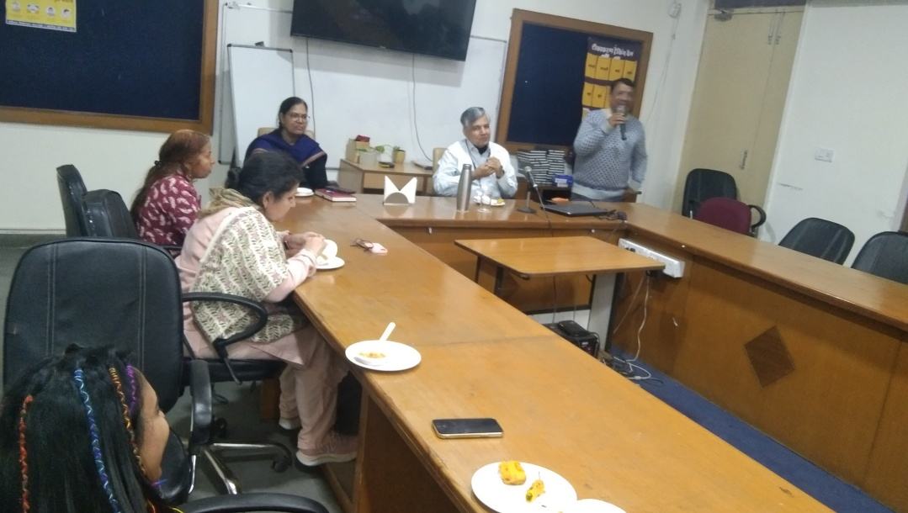

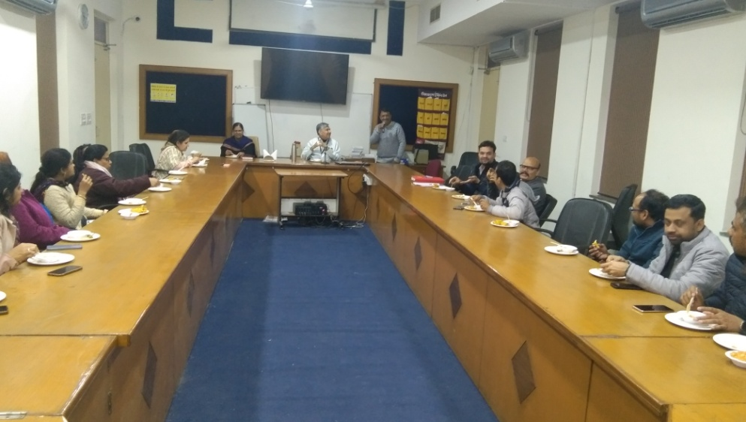

Workshops at SIHFW
Investigators Meeting-Cum Training Worksop

This 2 days training workshop was organised at SIHFW on December 2-3, 2023. It was organised under ICMR-PCOS Cohort Study Phase-II. This workshop was organised by SMS Medical College, Jaipur.
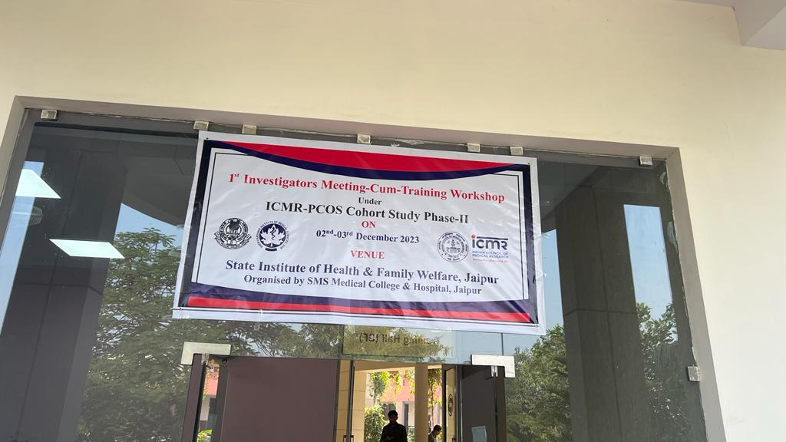

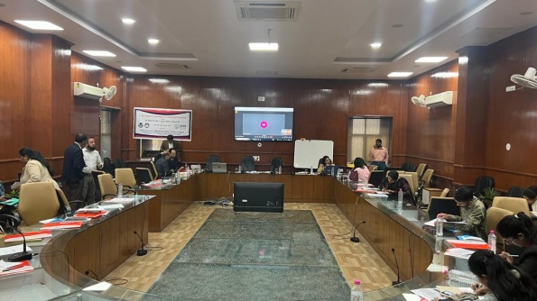

Trainings at SIHFW
Training of Trainers (ToT)
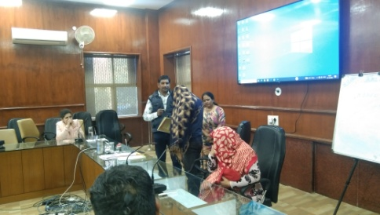
ASHA ToT
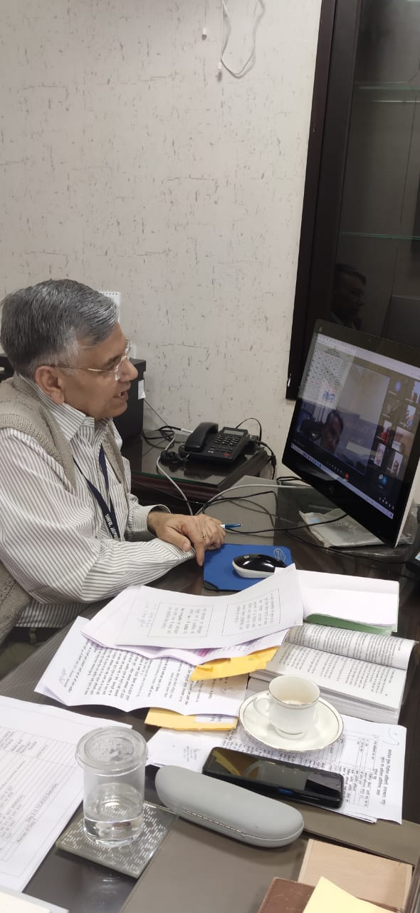
This training is at present longest duration training organised at SIHFW. This is a 15 days Hybrid training where 8 days online sessions are organised and 7 day offline sessions are organised at SIHFW. Training batch was organised during December 1 to 18, 2023 at SIHFW and 21 participants were trained including CHO, NO, AMN, SHS. During offline sessions, participants are trained on skill hands-on practice, with skill demonstration. Participants appear in skill assessments based on OSCI, mock sessions and written paper. Only when participants qualify passing marks, they can become District trainers to give training to ASHA workers. Training methodology also includes Case discussions, written assignments, Role play, lecture methods, etc.
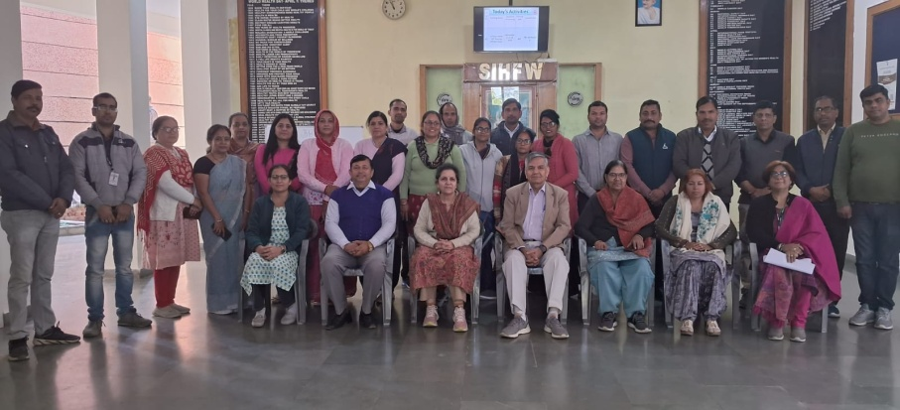
Director sir SIHFW addressing participants in online sessions of ASHA ToT.
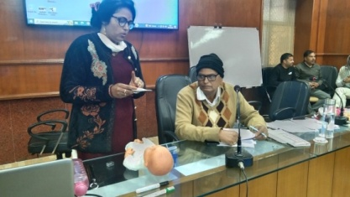
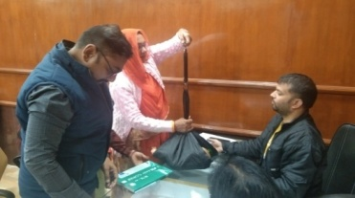
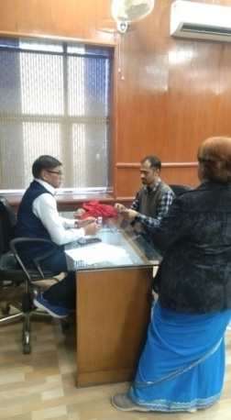

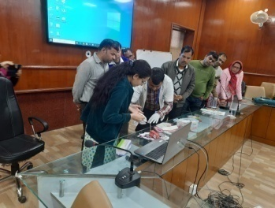
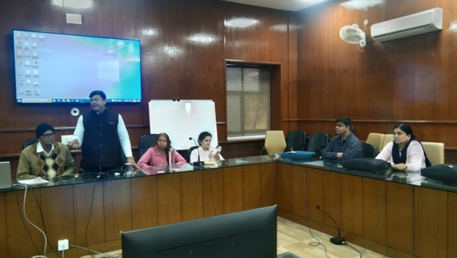

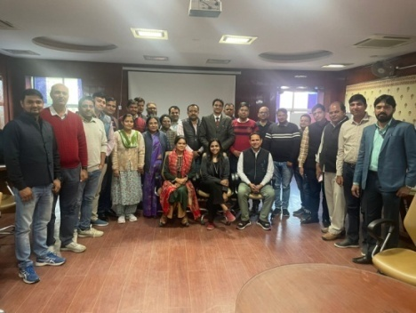
ToT for Jan Arogya Samiti
First ToT batch were organised on Jan Arogya Samiti (JAS) at SIHFW. This is a 2 day ToT. It was organised at SIHFW on December 11-12, 2023. This is an innovation under HWC programme. Medical Officers, PHN and Nursing Tutors participated in these batches of ToT. 39 State Trainers are developed in this State ToT, followed by this ToT, there will be ToT batches at Zonal Headquarters. Further all trainers will provide JAS training to all HWC staff.
ToT on PLA
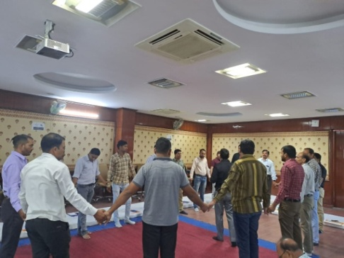
This ToT is organised on Participatory Learning in Action (PLA). This batch was organised for 5 districts- Ajmer, Pali, Rajsamand, Chittorgarh and Jhalawar. Participants include BHS and PHS. One batch was organised on October 26-27, 2023.
This training is organised at SIHFW in coordination with Development organizations IPE Global and Ekjut. Sitting arrangement for this training is done on floor with dari and mattresses because this training has relevance with village level field work. Participants of this training will work with staff and community for developing village social maps of available resources and develop village plans with community involvement. 23 participants were trained in this batch who will organize PLA sessions at field level involving community members and field functionaries.

ToT HBYC
Two batches of 3 days Home Based care for Young Child Programme (HBYC) ToT were organised at SIHFW. These batches were organised on October 3 to 5 and October 9 to 11, 2023. Participants trained in this ToT will provide training to ASHA on HBYC visits at field level. HBYC programme focuses on reducing child morbidity and mortality and for promotion of growth and Early childhood development. Under HBYC, ASHA provides incentivized five home visits on 3rd, 6th, 9th, 12th and 15 months.
Other trainings at SIHFW
Routine Immunization training for Medical Officers
Routine Immunization training is of 3 days duration organised for Medical Officers at SIHFW. Training batches always scheduled such that first day of training is on Tuesday so that participants get an exposure visit of Routine Immunization session planned on Thursdays (MCHN day). Immunization schedule, AEFI, Cold chain, Vaccine Management etc are the components of this training. 10 RI training batches were organised at SIHFW during October to December 2023. Total 28 batches are completed till December 2023.
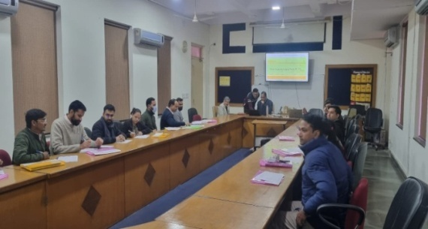
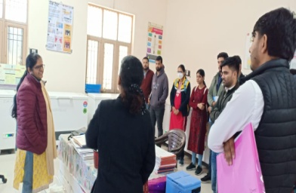
Dr Lokesh Chaturvedy, Director RCH monitoring the RI training at SIHFW
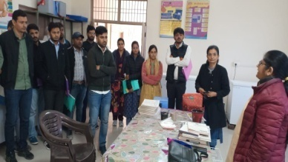

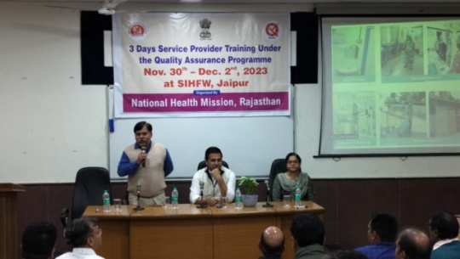
Quality Assurance Training
Service Provider cum Internal Assessor Training batches were organised at SIHFW in December 2023. These batches were organised by State Quality Cell, NHM. This is a 3 days training and NQAS Assessors participated at this training. In batch organised on November 30 to December 2, 2023, MD-NHM Shri Jitendra Kumar Soni sir was Chief Guest. In other batch organised during December 6-8, 2023, Director RCH presented the key note address.
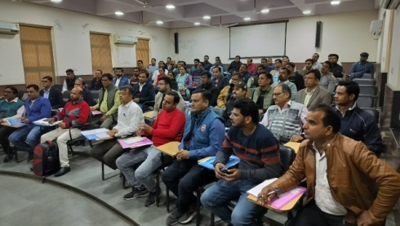
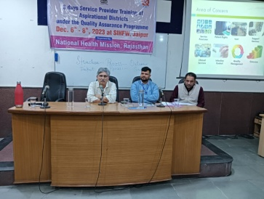
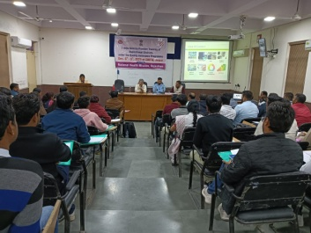

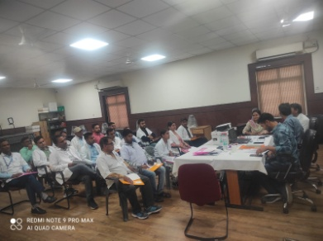
Laboratory Technicians training
With objective of imparting knowledge about Malaria under NVBDCP, laboratory technicians/Laboratory Assistants are trained at SIHFW in 5 days training. Make shift Laboratory equipped with microscopes is established in a training hall at SIHFW for this type of training. Participants are trained by Nodal Officer, Malaria programme (NVBDCP) and senior Laboratory technicians/ Lab assistants on appropriate sampling and diagnosis of Malaria. This is a hands-on skill development training. 5 batches have been organised at SIHFW for Laboratory Technicians during October to December 2023. Total 10 batches of this training are completed till December 2023.

Child Death Review
Trainings on Child Death Review (CDR) are organised at SIHFW. 7 batches of this one day training were organised during October to December 2023.

Field Trainings organised by SIHFW
CAC training

This is a 12 days training organised at District level, where selected centres have been developed for this training. This is a clinical training and total 22 batches of this training are completed and 81 participants were trained till December 2023 by SIHFW.

SBA training and SBA Refresher Training

Nursing staff are provided SBA training of 21 days at District Hospitals. 17 batches of SBA training are completed till December 2023. Participants are given classroom learning and hands-on learning at labour rooms and ANC wards at District Hospitals. Trained SBA participants are also provided a refresher training of 3 days after completing 3 years of SBA training. 4 batches of 6 days Refresher have been organised by SIHFW.

Medical Method of Abortion (MMA) Training

This is a clinical training organised at District Hospitals for Medical Officers. 4 batches have been organised by SIHFW.

Routine Immunization for Health Workers

This is a 2 days Routine Immunization training for Health workers, such as Nursing staff, ANM, GNM. This training is organised at District level by SIHFW. Total 25 batches have been organised till December 2023.

CHO Induction training

This training is of 15 days duration and it is organised by SIHFW under HWC program for newly recruited CHOs, at District level.

HWC – Training on Extended services in Districts

These trainings are organised for various cadres of Health and Wellness Care Centres (HWC) such as Medical Officers, ANM, Staff Nurse and ASHA. Participants are trained on seven components-Mental and Neurological Substance Abuse, Elderly, Palliative, Oral, Eye, ENT and Emergency Services. These training are organised at District level under 15th Finance Commission (2022-23) and PIP 2023-24.
Picture Gallery of Field trainings
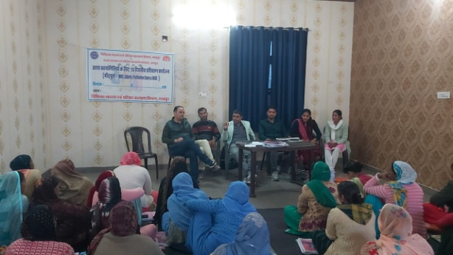
HWC-ASHA Training at District Bharatpur,
Training monitoring done by Dy CMHO of Bharatpur

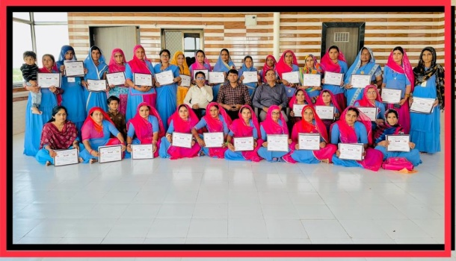

HWC ASHA Training batch organised at District Barmer
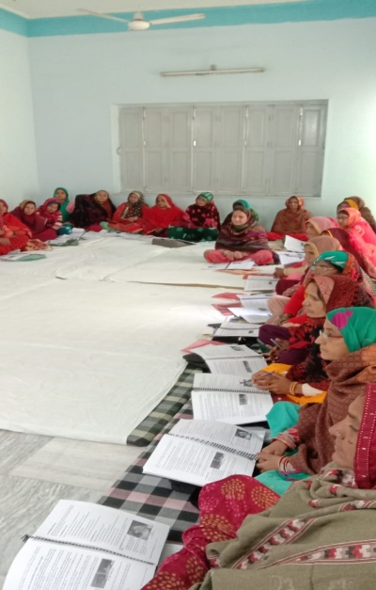

HWC ASHA Training batch organised at District Churu

NSV training at Rajsamand, Pali and Karauli districts

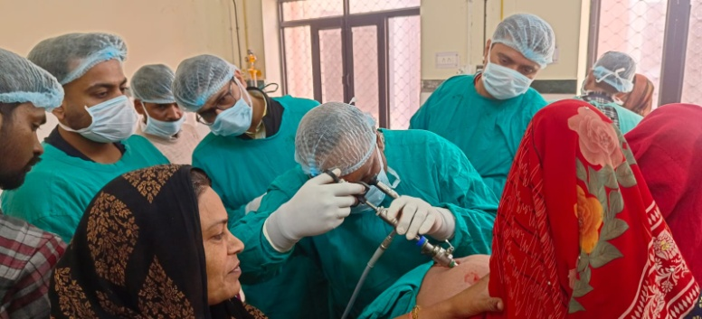
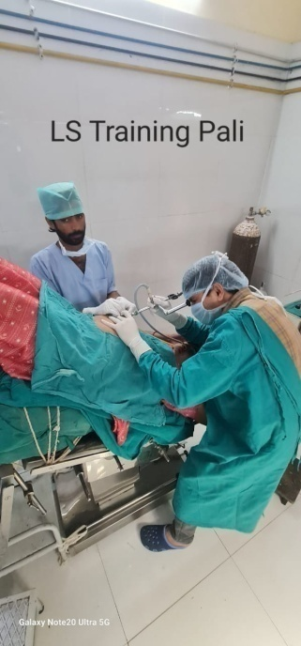

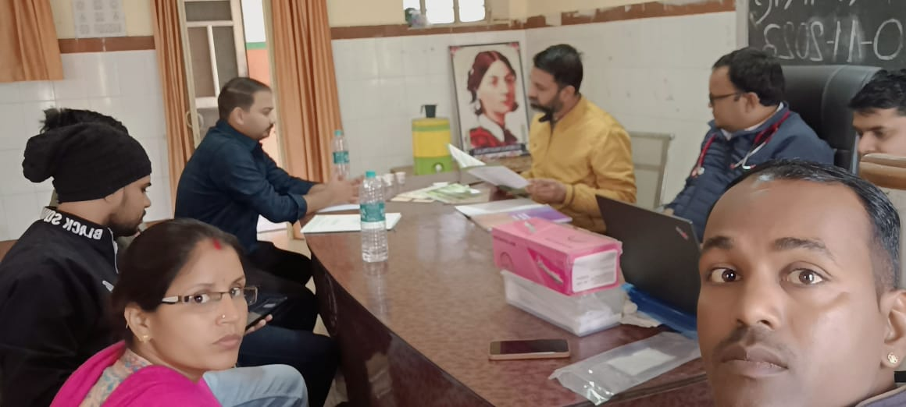

District Training Monitoring
Dausa district monitoring

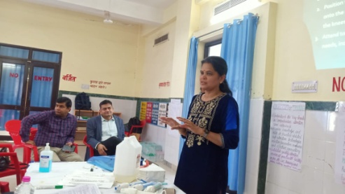
Dr Rajni Singh, Research Officer at SIHFW did monitoring of training at Dausa District. Training batch of Comprehensive Abortion Care (CAC) was organised at District Hospital Dausa on December 4-6, 2023. Monitoring was done on December 5, 2023.

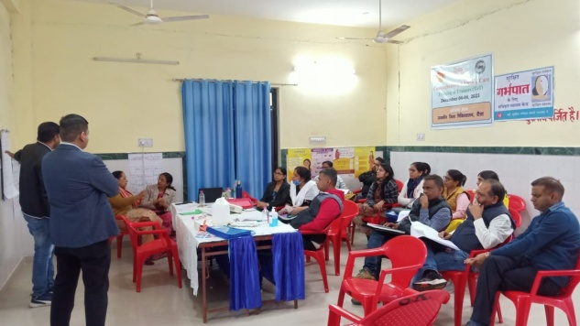

Health News

India registered 9.3 lakh cancer deaths, second highest in Asia: LANCET study

India registered about 12 lakh new cancer cases and 9.3 lakh deaths in 2019, becoming the second highest contributor to the disease burden in Asia for that year, according to a new study published in The Lancet Regional Health Southeast Asia journal.

Researchers found that India, along with China and Japan, were the three leading countries in Asia in terms of number of new cases and deaths, where they say cancer has become a more significant public health threat with 94 lakh new cases and 56 lakh deaths in 2019. According to the Research:-

- Of these, while China contributed the most with 48 lakh new cases and 27 lakh deaths, Japan recorded about nine lakh new cases and 4.4 lakh deaths
- In Asia, the leading cancer was that of tracheal, bronchus, and lung (TBL), resulting in an estimated 13 lakh cases and 12 lakh deaths. It was also found to be most frequent in men and third most frequent in women.
- Specifically among women, cervical cancer is ranked second or among top-five cancers in several Asian countries. The human papillomavirus (HPV) vaccine, introduced in 2006, has proved to be effective in preventing the disease and reducing HPV-related deaths.
- Overall, in the continent and individual countries, TBL, breast, colon and rectum cancer (CRC), stomach and non-melanoma skin cancer were among the top five most frequent cancers in 2019 with few countries having leukemia, prostate, liver and pancreatic cancers in the list.
- smoking, alcohol consumption and ambient particulate matter (PM) pollution remained dominant among the 34 risk factors for cancer. The rising cancer burden due to increasing ambient air pollution is concerning in Asia.
- Five of the top 10 countries with regards to population-weighted annual average of PM2.5 in 2019 are present in Asia — India, Nepal, Qatar, Bangladesh and Pakistan.
- Primary reasons for increasing air pollution in Asia were industry-led economic growth along with urbanisation, rural-to-urban migration and increasing usage of motor vehicles.
- A high prevalence of smokeless tobacco (SMT) such as khaini, gutkha, betel quid and paan masala is a public health concern in South Asian countries such as India, Bangladesh, and Nepal, with India alone accounting for 32.9% of global deaths and 28.1% of new cases of lip and oral cavity cancer in 2019.
- More than 50% of the oral cancer burden has been attributed to smokeless tobacco, whose prevalence has grown in recent times in South Asia, including India.
- SMT not only increases the risk of oral cancers but also enhances the risk of esophageal and pancreatic cancer,” they said. They wrote that improved water and sanitation can help reduce the transmission of Helicobacter pylori (H. pylori) and, in turn, potentially lower the risk of stomach cancer.
- A raised burden of cancers associated with longer lifespan such as prostate, pancreatic and breast cancer over the same time period.
- In the low- and medium-income countries (LMICs) of Asia, oncologic infrastructure is either scarce or unaffordable, particularly in rural areas. Combined with a weak referral system, patients end up getting delayed diagnosis and treatment, leading to lower survival rates.
- Mere availability of screening might not improve the survival rates if cancer treatments are either unavailable or unaffordable. Therefore, along with timely availability of cancer screening and treatment, its cost-effectiveness or coverage of treatment expenses must also be a policy priority.
- A reduced burden of cancers such as leukemia among those under five years of age between 1990 and 2019.
Source: The Hindu, January 3, 2024

Update on Mental Health Services In Rural Areas
For providing affordable and accessible mental healthcare facilities in the country, the Government is implementing the National Mental Health Programme (NMHP) in the country. The District Mental Health Programme (DMHP) component of the NMHP has been sanctioned for implementation in 738 districts for which support is provided to States/UTs through the National Health Mission. Facilities made available under DMHP at the Community Health Centre (CHC) and Primary Health Centre (PHC) levels, include outpatient services, assessment, counselling/ psycho-social interventions, continuing care and support to persons with severe mental disorders, drugs, outreach services, ambulance services etc. In addition to above services there is a provision of 10 bedded in-patient facility at the district level.
Besides the above, the Government has launched a “National Tele Mental Health Programme” on 10th October, 2022, to improve access to quality mental health counselling and care services in the country. As on 04.12.2023, 34 States/ UTs have set up 46 Tele MANAS Cells and have started tele mental health services and more than 4,81,000 calls have been handled on the helpline.
Under the tertiary care component of NMHP, 25 Centres of Excellence have been sanctioned to increase the intake of students in PG departments in mental health specialities as well as to provide tertiary level treatment facilities. Further, the Government has also supported 19 Government medical colleges/institutions to strengthen 47 PG Departments in mental health specialties. Mental Health Services are also provisioned for 22 AIIMS. These services are also available under PMJAY.
Under Pradhan Mantri Jan Arogya Yojana (PMJAY), health insurance cover of Rs. 5 lakhs per family per year for secondary or tertiary care hospitalization to over 60 cr. beneficiaries is provided. The treatment packages under AB-PMJAY are very comprehensive covering various treatment related aspects such as drugs and diagnostic services. Mental health services are also covered under PMJAY.

The Government conducted the National Mental Health Survey (NMHS), 2016 of India through the National Institute of Mental Health and Neurosciences (NIMHANS), Bengaluru in 12 States of the country, as per which the prevalence of mental disorders in adults over the age of 18 years is about 10.6%. Further, as per the Survey, the prevalence of mental morbidity is higher in urban metro regions (13.5%) as compared to rural areas (6.9%) and urban non-metro areas (4.3%).

Source: December 8, 2023, PIB

Significant Progress made under the Ni-Kshay Mitra Abhiyan
The World Health Organization released its Global TB Report 2023 on 7th November. According to the report, India has made tremendous progress in improving case detection and reversed the impact of COVID-19 on the TB programme. The treatment coverage has improved to 80% of the estimated TB cases, an increase of 19% over the previous year.
India’s efforts have resulted in reduction of TB incidence by 16% in 2022 (from 2015) almost double the pace at which global TB incidence is declining (which is 8.7%). The mortality of TB has also reduced by 18% during the same period in India and globally. The World Health Organization has made a downward revision of the TB mortality rates from 4.94 lakhs in 2021 to 3.31 lakhs in 2022, a reduction of over 34%.
The WHO team intensively reviewed all data presented and not only accepted, but also appreciated the efforts made by the country. This year, the Global TB Report has acknowledged and published the revised estimates for India with downward revision of the burden estimates, especially TB related mortality figures.
The report notes that India’s intensified case detection strategies have resulted in the highest ever notification of cases – in 2022, during which, over 24.22 lakh TB cases were notified, surpassing the pre-COVID levels. The key initiatives launched and scaled up by the government like specialised active case finding drives, scaling up of molecular diagnostics to block levels, decentralization of screening services through Ayushman Bharat Health & Wellness Centres and private sector engagement have resulted in significantly bridging the gap in missing cases.
The Pradhan Mantri TB Mukt Bharat Abhiyan has received a tremendous response across the country with over 1 lakh Ni-kshay Mitras from all walks of life coming forward to adopt over 11 lakh TB patients. Under Ni-kshay Poshan Yojana about Rs 2613 Cr have been disbursed to over 95 lakh TB patients since its launch in 2018. Newer patient centric initiatives like Family Care Giver Model and Differentiated Care have been introduced to ensure further reduction in mortality and improvement in treatment success rates.
The report also notes that India has taken bold steps to prioritize TB elimination efforts with investing additional resources to the National TB Elimination Programme being implemented under the aegis of the National Health Mission. Source: November 8, 2023, PIB

We solicit your feedback:
Editing and Compilation by: Archana Saxena, RO; IT support: Mohit Dhonkeriya;
Mentored by: Dr Sunita Thakan, Faculty-Gynaecologist, SIHFW
State Institute of Health & Family Welfare
Jhalana Institutional Area, South of Doordarshan Kendra Jaipur (Raj)
Phone-2706534
E-mail:-sihfwraj@ymail.com; Website: www.sihfwrajasthan.com

